**UNIT-I: Introduction to Computer Networks and Physical Layer(CN)**

Introduction to Computer Networks:

Computer networks are an essential part of modern communication and information sharing. They allow multiple devices, such as computers, smartphones, servers, and other electronic devices, to connect and exchange data with each other. A computer network can be as simple as two devices connected together or as complex as a global network like the Internet.

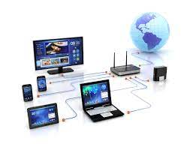

The primary purpose of a computer network is to facilitate the sharing of resources, information, and services among connected devices. These resources can include files, printers, applications, and even processing power. Networks enable users to access information from remote locations, collaborate with others, and communicate in real-time.

Types of Computer Networks:

1. Local Area Network (LAN): A LAN is a network that spans a limited geographical area, typically within a building or a campus. LANs are commonly used in homes, offices, and schools to connect devices such as computers, printers, and servers.
2. Wide Area Network (WAN): A WAN covers a larger geographical area, often connecting multiple LANs or remote locations. The Internet is the most prominent example of a wide-area network that spans the globe.
3. Metropolitan Area Network (MAN): A MAN falls between a LAN and WAN in terms of geographic coverage. It covers a larger area than a LAN but is typically confined to a city or a metropolitan area.
4. Personal Area Network (PAN): A PAN is a network used for communication between devices in close proximity to a single person. For example, connecting a smartphone to wireless earbuds or a smartwatch would create a PAN.

Components of a Computer Network:

1. Nodes: These are the devices connected to the network, such as computers, routers, switches, and servers.
2. Links: Links are the physical connections between nodes, which can be wired (e.g., Ethernet cables, fiber optics) or wireless (e.g., Wi-Fi, Bluetooth).
3. Network Interface Card (NIC): A NIC is a hardware component that allows a device to connect to the network and communicate with other devices.
4. Switches: Switches are devices that facilitate communication between devices within a local network. They forward data only to the intended recipient, making data transmission more efficient.
5. Routers: Routers are devices that connect different networks together. They determine the best path for data packets to reach their destination, which is especially important in wide-area networks.

Introduction to the Physical Layer:

The Physical Layer is the first and lowest layer of the OSI (Open Systems Interconnection) model and plays a fundamental role in computer networks. It deals with the physical aspects of data transmission and focuses on transmitting raw binary data over a physical medium, such as cables or wireless channels.

Functions of the Physical Layer:

1. Physical Connection: The Physical Layer is responsible for establishing, maintaining, and terminating physical connections between devices. It defines the characteristics of the physical medium used for data transmission, including the type of cable, connectors, and hardware interfaces.
2. Physical Topology: The Physical Layer defines the physical layout of the network, including how devices are connected to each other.
3. Data Encoding: It is responsible for converting digital data into signals suitable for transmission over the physical medium. This process involves modulation techniques, where the data is modulated onto carrier signals.
4. Signal Transmission: The Physical Layer manages the transmission and reception of signals between devices on the network.
5. Signal Reception and Interpretation: It handles the reception of signals from the physical medium and converts them back into a digital format that upper layers of the OSI model can understand.
6. Bit Synchronization: Ensures that the sender and receiver are synchronized in terms of the timing of the transmitted bits.

Common Physical Layer Components:

1. Cables: Twisted Pair, Coaxial, Fiber-optic cables are commonly used to transmit signals over wired networks.
2. Network Interface Cards (NICs): These are physical devices installed on computers and other devices to connect them to the network.
3. Hubs and Repeaters: Hubs (deprecated) and repeaters are devices used to extend the reach of a network by amplifying and regenerating signals.
4. Modems: Modems are used to convert digital data into analog signals for transmission over telephone lines (used in earlier dial-up connections).
5. Wireless Transmitters/Receivers: In wireless networks, antennas and transceivers are used to send and receive signals over the air.

The Physical Layer forms the foundation for higher layers of the OSI model, allowing data to be transmitted reliably across networks and enabling the functionality of upper layers in the network protocol stack.

**Network Topologies WAN, LAN, MAN**

Network Topologies:

Network topology refers to the physical or logical layout of devices and connections in a computer network. It defines how devices are interconnected and how data flows between them. There are three primary types of network topologies: LAN (Local Area Network), WAN (Wide Area Network), and MAN (Metropolitan Area Network).

1. Local Area Network (LAN):

A Local Area Network (LAN) is a network that covers a limited geographic area, typically within a building, campus, or a small group of nearby buildings. LANs are commonly used in homes, offices, schools, and small businesses. The devices in a LAN are connected using wired or wireless technology, allowing for easy communication and resource sharing among connected devices.

Characteristics of LANs:

* Limited geographic area: LANs cover a small physical area, often confined to a single building or a group of nearby buildings.
* High data transfer rates: LANs usually offer high-speed data transfer rates, providing fast communication between devices.
* Low latency: With devices in close proximity, latency (time delay) is minimal, resulting in quick data transmission.
* Cost-effective: LAN hardware is relatively inexpensive, making it affordable for small-scale networks.
* Common LAN topologies: LANs can use various topologies like star, bus, ring, or mesh, depending on the organization's needs and requirements.
* 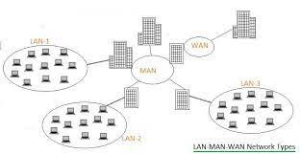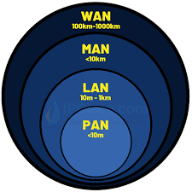

1. Wide Area Network (WAN):

A Wide Area Network (WAN) is a network that covers a large geographical area, often spanning cities, countries, or even continents. WANs connect multiple LANs or other networks, enabling data transmission and communication over long distances. The Internet is the most extensive and well-known example of a WAN.

Characteristics of WANs:

* Large geographic coverage: WANs cover extensive geographical areas, often crossing multiple cities or countries.
* Public and private infrastructure: WANs may utilize public infrastructure (e.g., the Internet) or private leased lines to establish connections between distant locations.
* Slower data transfer rates: Compared to LANs, WANs typically have slower data transfer rates due to the longer distances data must travel.
* Higher latency: Longer distances result in higher latency in WANs, leading to increased time delays.
* WAN optimization techniques: Various techniques like data compression, caching, and traffic shaping are used to improve WAN performance.

1. Metropolitan Area Network (MAN):

A Metropolitan Area Network (MAN) is a network that falls between a LAN and a WAN in terms of geographic coverage. It spans a larger area than a LAN but is typically confined to a city or a metropolitan region.

Characteristics of MANs:

* Medium geographic coverage: MANs cover larger areas than LANs but are smaller in scale than WANs, typically spanning a city or metropolitan region.
* Interconnectivity: MANs connect multiple LANs and data centers within the city or metropolitan area.
* High-speed connectivity: MANs often offer high-speed connections to support data-intensive applications and services.
* MANs are commonly used by organizations, institutions, and service providers to connect different locations within a city or metropolitan area.

**Reference models**

Reference models provide a conceptual framework for understanding how different protocols and network components interact and work together to enable communication in computer networks. Two of the most well-known reference models are the OSI Reference Model and the TCP/IP Reference Model.

**The OSI Reference Mode**

The OSI Reference Model, also known as the OSI Model or OSI 7-Layer Model, is a conceptual framework that standardizes the functions of a telecommunication or computing system into seven distinct layers. It was developed by the International Organization for Standardization (ISO) to facilitate communication between different computer systems and network devices. The OSI model helps in understanding and designing complex networks by breaking down the communication process into modular and manageable components.

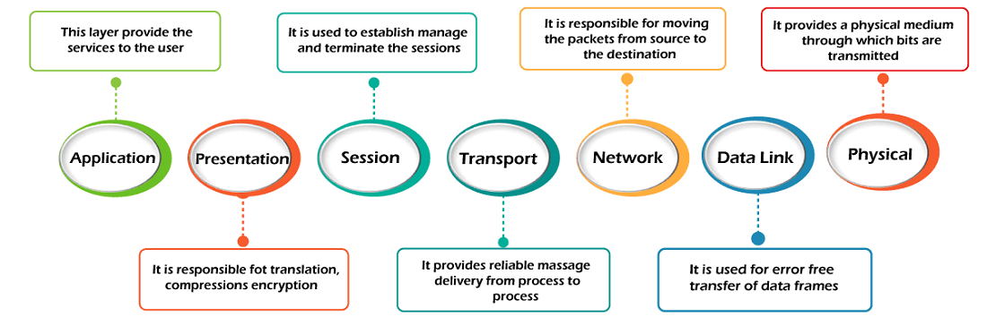

The seven layers of the OSI Reference Model, from the top layer to the bottom layer, are as follows:

1. Application Layer (Layer 7):

This is the topmost layer and is closest to the end-users or applications. It provides network services directly to user applications, enabling communication between software applications and the network. Examples of protocols at this layer include HTTP (for web browsing), SMTP (for email), and FTP (for file transfer).

1. Presentation Layer (Layer 6):

The Presentation Layer is responsible for data formatting, encryption, and compression. It ensures that data from different systems can be properly interpreted by translating the data into a standard format. This layer handles data representation and conversion, such as ASCII to EBCDIC conversion or data encryption/decryption.

1. Session Layer (Layer 5):

The Session Layer manages sessions and dialogues between applications. It establishes, maintains, and terminates connections between systems. This layer handles functions like session establishment, synchronization, and checkpointing to support ongoing communication between applications.

1. Transport Layer (Layer 4):

The Transport Layer provides reliable end-to-end data delivery and ensures error recovery and flow control. It segments data received from the upper layers into smaller packets, manages acknowledgment and retransmission of data, and ensures that data is delivered in the correct order. Two common transport layer protocols are Transmission Control Protocol (TCP) and User Datagram Protocol (UDP).

1. Network Layer (Layer 3):

The Network Layer is responsible for routing and forwarding data packets between different networks. It deals with logical addressing (e.g., IP addresses) and determines the best path for data transmission. Routers operate at this layer and make decisions about how to direct data packets toward their destination.

1. Data Link Layer (Layer 2):

The Data Link Layer provides reliable data transfer between two directly connected devices on the same network. It is divided into two sub-layers: Logical Link Control (LLC) and Media Access Control (MAC). The LLC sub-layer handles flow control and error checking, while the MAC sub-layer manages access to the physical transmission medium.

1. Physical Layer (Layer 1):

The Physical Layer deals with the physical medium of data transmission, such as cables, switches, and network interface cards. It defines the electrical, mechanical, and procedural aspects of data transfer. This layer converts binary data into electrical, optical, or radio signals for transmission over the physical medium.

**Each** layer of the OSI Reference Model has a specific set of functions, and communication between layers is standardized through well-defined interfaces. This layered approach allows network designers and engineers to develop and troubleshoot networks more efficiently by isolating specific functionalities within each layer. Additionally, it promotes interoperability between different vendors' networking products and facilitates the development of new networking technologies and protocols.

**the TCP/IP Reference Mode**

The TCP/IP Reference Model, also known as the TCP/IP Protocol Suite, is a practical implementation of the protocols used in the Internet and is the foundation of modern networking. Unlike the OSI Reference Model, the TCP/IP model consists of four layers. It was developed by the U.S. Department of Defense in the 1970s to create a standardized and scalable protocol suite for computer networks, specifically for military and research purposes.

The four layers of the TCP/IP Reference Model, from the top layer to the bottom layer, are as follows:

1. Application Layer:

The Application Layer corresponds to the combined functions of the top three layers (Application, Presentation, and Session) of the OSI model. It is responsible for providing network services directly to user applications. This layer includes various application-specific protocols, such as HTTP (for web browsing), FTP (for file transfer), SMTP (for email), and DNS (for domain name resolution).

1. Transport Layer:

The Transport Layer is similar to the OSI Transport Layer and is responsible for ensuring reliable data delivery and end-to-end communication between applications. It provides services for segmentation, reassembly, error recovery, and flow control. The two most common transport layer protocols in the TCP/IP model are TCP (Transmission Control Protocol) and UDP (User Datagram Protocol).

1. Internet Layer:

The Internet Layer corresponds to the OSI Network Layer and is responsible for handling packet routing and forwarding. It deals with logical addressing (IP addresses) and determines the best path for data transmission across interconnected networks. The primary protocol at this layer is the Internet Protocol (IP).

1. Link Layer (also known as Network Access Layer):

The Link Layer is similar to the OSI Data Link Layer and is responsible for reliable data transfer between directly connected devices on the same network. It includes both the Logical Link Control (LLC) and Media Access Control (MAC) sub-layers. The Link Layer is closely tied to the physical medium and includes protocols such as Ethernet, Wi-Fi, and PPP.

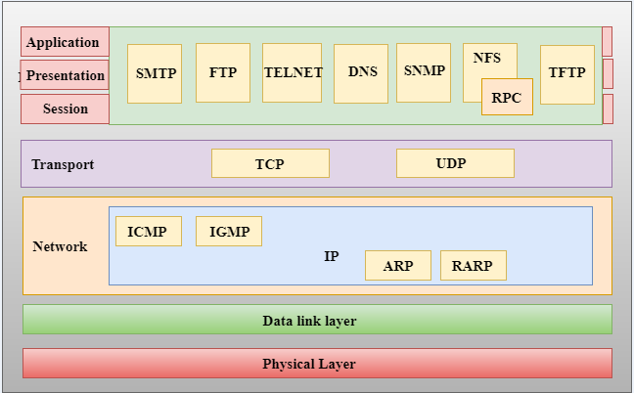

**Comparison of OSI and TCP/IP Reference Models:**

1. Number of Layers: OSI: Seven layers, TCP/IP: Four layers
2. Layer Names and Functions: While both models have layers that deal with similar functionalities, their naming and division differ. For example, the Transport Layer in OSI corresponds to the TCP/IP Transport Layer.
3. Encapsulation: Both models use a process called "encapsulation" to add headers and trailers to data as it passes down the layers. However, the specific headers and trailers used in each model differ.
4. Adoption and Implementation:

* The OSI model is mainly used for educational purposes and as a conceptual reference. It is not widely implemented in real-world networks.
* The TCP/IP model is the basis for the Internet and is widely used in practical networking, as TCP/IP protocols dominate modern communication.

1. Flexibility and Scalability: The TCP/IP model is considered more flexible and scalable due to its streamlined design.
2. Relation to Real-World Protocols:

* The OSI model does not directly map to specific real-world protocols but provides a reference for understanding network communication concepts.
* The TCP/IP model closely aligns with the actual protocols used in the Internet, such as HTTP, FTP, TCP, UDP, IP, etc.

**Example Networks**

1. Home Wi-Fi Network:

* Scale: Small
* Purpose: Provides internet connectivity and local network services within a home or small apartment.
* Components: A wireless router or access point that connects to the internet, along with wireless devices (laptops, smartphones, smart TVs) and wired devices (desktop computers, gaming consoles) connected to the router.

1. Small Office or Small Business Network:

* Scale: Small to Medium
* Purpose: Facilitates communication, data sharing, and resource sharing within a small office or business environment.
* Components: Network switches, wireless access points, router/firewall, file server, printers, desktop computers, and other networked devices.

1. Enterprise Local Area Network (LAN):

* Scale: Large
* Purpose: Supports a large organization or corporation with multiple departments and locations, providing seamless communication and resource sharing.
* Components: High-capacity network switches, routers, firewalls, load balancers, server farms, data centers, storage area networks (SANs), and various networked devices like computers, printers, and VoIP phones.

1. Campus Area Network (CAN):

* Scale: Large
* Purpose: Connects multiple buildings and facilities within a college campus or university, enabling students, faculty, and staff to access shared resources and services.
* Components: High-speed network backbone, distribution switches, wireless access points, computer labs, libraries, administrative buildings, and data centers.

1. Metropolitan Area Network (MAN):

* Scale: Large
* Purpose: Covers a city or metropolitan area, connecting multiple LANs, data centers, and service providers, supporting communication and data exchange across different parts of the city.
* Components: High-capacity network equipment, fiber-optic cables, microwave links, and various nodes connecting different local networks and data centers.

1. Wide Area Network (WAN):

* Scale: Very Large (Geographically Dispersed)
* Purpose: Connects geographically dispersed locations, such as offices in different cities or countries, to create a unified network infrastructure for data exchange and communication.
* Components: High-speed dedicated leased lines, virtual private networks (VPNs), routers, switches, and multiple interconnected LANs.

1. The Internet:

* Scale: Global
* Purpose: The largest and most widely known network, connecting billions of devices worldwide and enabling global communication, information sharing, and online services.
* Components: An intricate network of interconnected networks, data centers, Internet Service Providers (ISPs), Tier 1 backbone providers, undersea cables, satellites, and a vast array of devices and servers.

**Fourier Analysis**

Fourier Analysis is a mathematical technique used to analyze and represent complex waveforms or signals as a sum of simpler sinusoidal components. It is named after the French mathematician and physicist Joseph Fourier, who first introduced the concept in the early 19th century. Fourier Analysis is widely applied in various fields, including signal processing, engineering, physics, telecommunications, and data analysis.

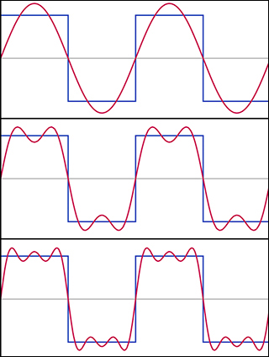

The key idea behind Fourier Analysis is that any periodic or non-periodic waveform can be broken down into a combination of individual sine and cosine waves, each with specific frequencies, amplitudes, and phases. These individual sine and cosine waves are referred to as "harmonics" or "frequency components."

The primary components of Fourier Analysis are as follows:

1. Time-Domain Signal: A time-domain signal is a representation of a waveform as a function of time. It shows how the signal varies over time and provides information about its amplitude, frequency, and shape.
2. Frequency-Domain Representation: The frequency-domain representation of a signal shows its frequency components and how much of each frequency is present in the signal. In this representation, the x-axis represents the frequencies, and the y-axis represents the magnitude or amplitude of each frequency component.

The process of converting a time-domain signal to its frequency-domain representation is known as a Fourier Transform. There are two main types of Fourier Transform:

a. Continuous Fourier Transform (CFT): The CFT is used for continuous, non-periodic signals. It transforms a continuous-time signal into its frequency-domain representation.

b. Discrete Fourier Transform (DFT): The DFT is used for discrete, periodic or non-periodic signals. It transforms a discrete-time signal (sampled at specific time intervals) into its frequency-domain representation.

Applications of Fourier Analysis:

1. Signal Processing: Fourier Analysis is extensively used in signal processing to analyze and modify signals in various applications such as audio processing, image processing, speech recognition, and data compression.
2. Telecommunications and Networking: In telecommunications and networking, Fourier Analysis plays a vital role in modulating and demodulating signals for data transmission over channels with specific frequency responses.
3. Electrical Engineering: Fourier Analysis is employed in analyzing electrical waveforms in circuits and systems, such as analyzing voltage and current signals in electronics.
4. Audio and Music: It is used in audio and music processing to understand and manipulate sound signals, enabling tasks such as noise reduction, equalization, and audio synthesis.
5. Physics and Engineering: Fourier Analysis is utilized in various scientific and engineering disciplines to study phenomena with periodic or repetitive characteristics, such as vibrations, heat transfer, and electromagnetic wave propagation.

**Bandwidth Limited Signals**

Bandwidth-limited signals are signals that have a limited range of frequencies they can effectively transmit or carry. In practical communication systems, there is a finite range of frequencies available for data transmission, and each communication channel or medium has a specific bandwidth that defines the range of frequencies it can accommodate.

In the context of bandwidth-limited signals, the bandwidth refers to the range of frequencies within which the signal can maintain its integrity and be reliably transmitted without significant distortion or loss of information. The bandwidth is usually defined as the difference between the highest and lowest frequencies that the signal can effectively carry.

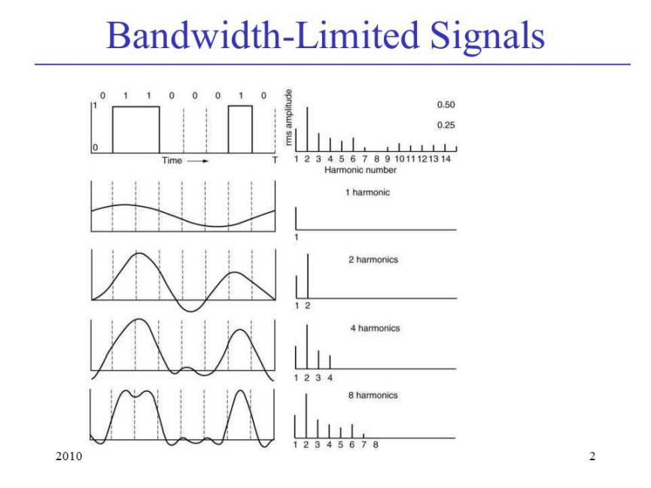

For example:

1. In analog communication systems, such as traditional voice calls over a telephone line, the bandwidth of the channel typically limits the range of audio frequencies that can be transmitted. The human voice contains frequencies from around 300 Hz to 3,400 Hz, and the channel bandwidth needs to be wide enough to accommodate this range of frequencies to ensure clear communication.
2. In digital communication systems, such as wired or wireless data networks, the bandwidth of the channel dictates the maximum data rate that can be transmitted over the network. Higher bandwidth allows for faster data transmission rates, while lower bandwidth limits the data rate.
3. In optical fiber communication, the bandwidth of the optical fiber determines the range of optical frequencies that can be used for data transmission. Optical fibers can support very high bandwidths, making them ideal for transmitting large amounts of data over long distances.

In practice, bandwidth-limited signals require careful design and management to ensure efficient and reliable communication. Various communication technologies and techniques, such as modulation schemes, multiplexing, and equalization, are employed to optimize the use of available bandwidth and maximize data transmission rates while minimizing interference and signal degradation.

**The Maximum Data Rate of a Channel Guided Transmission Media**

The maximum data rate of a channel using guided transmission media (such as copper cables or optical fibers) is determined by several factors, including the bandwidth of the channel and the signal-to-noise ratio (SNR). Shannon's Channel Capacity Theorem provides a theoretical limit on the maximum data rate for a given channel.

Shannon's Channel Capacity Theorem: The theorem, formulated by Claude Shannon in 1948, states that the maximum data rate (C) of a channel in bits per second (bps) is given by:

* C = B * log2(1 + SNR)

Where:

* C is the maximum data rate (channel capacity) in bps.
* B is the bandwidth of the channel in Hertz (Hz).
* SNR is the signal-to-noise ratio of the channel (measured in a linear scale).

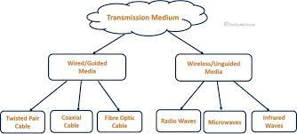

Key Considerations:

1. Bandwidth (B): The bandwidth of the channel is the range of frequencies over which the channel can effectively transmit signals. It is measured in Hertz (Hz). The higher the bandwidth, the more data can be transmitted simultaneously, leading to a higher data rate.
2. Signal-to-Noise Ratio (SNR): The SNR represents the ratio of the power of the transmitted signal to the power of the background noise in the channel. A higher SNR indicates a better signal quality relative to the noise, allowing for a higher data rate.
3. Noise and Interference: Noise and interference in the channel limit the quality of the signal, leading to a decrease in the achievable data rate. Techniques such as error correction and equalization are used to mitigate the impact of noise on data transmission.
4. Modulation and Encoding: The choice of modulation and encoding schemes affects how efficiently data is represented and transmitted over the channel. Advanced modulation techniques can increase the data rate.
5. Channel Characteristics: Different guided transmission media have unique characteristics that impact the maximum data rate. For instance, optical fibers offer higher bandwidth and lower signal attenuation compared to traditional copper cables, enabling higher data rates for fiber-optic communication.

**Multiplexing**

**Multiplexing is a technique used in communication systems to combine multiple signals or data streams onto a single communication channel, thereby increasing the overall capacity and efficiency of the channel. Here's a detailed explanation of three common multiplexing techniques:**

**Frequency Division Multiplexing (FDM)**

Frequency Division Multiplexing (FDM) is a multiplexing technique used in communication systems to combine multiple signals or data streams onto a single communication channel by dividing the available frequency bandwidth into non-overlapping sub-bands or channels. Each sub-band is allocated to a different signal, and each signal is modulated onto its specific frequency band before being transmitted over the channel.

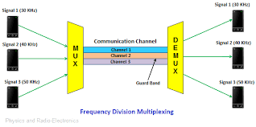

Key Concepts of Frequency Division Multiplexing (FDM):

1. Frequency Bands: FDM divides the frequency spectrum of the communication channel into separate frequency bands, each allocated to a different signal. These bands do not overlap, ensuring that each signal operates on its own specific frequency range.
2. Non-Interference: Since each signal operates on its unique frequency band, there is no interference between signals sharing the channel. The different signals coexist independently without affecting one another.
3. Analog Signal Transmission: FDM is commonly used in analog communication systems, where various audio or video signals are combined and transmitted simultaneously. For example, in cable TV systems, multiple TV channels are combined and sent over a single coaxial cable using FDM.

Process of Frequency Division Multiplexing:

1. Signal Modulation: Each input signal is individually modulated onto its assigned frequency band. Modulation converts the baseband signal (original signal) into a higher-frequency signal suitable for transmission over the channel.\
2. Signal Combination: After modulation, the individual signals are combined into a composite signal, which contains all the modulated sub-bands. The composite signal is then transmitted over the shared communication channel.
3. Signal Separation: At the receiving end, the composite signal is demultiplexed (demodulated) to separate the individual signals. Each signal is then demodulated to recover the original baseband signal.

Advantages of Frequency Division Multiplexing:

1. Simultaneous Transmission: Multiple signals can be transmitted simultaneously over the same communication channel without interfering with each other. This allows for efficient utilization of the available channel bandwidth.
2. Efficient Use of Frequency Spectrum: FDM enables the sharing of the frequency spectrum by allocating different bands to individual signals, making efficient use of available frequencies.
3. Compatibility with Analog Signals: FDM is well-suited for analog signal transmission, making it suitable for applications like cable TV, radio broadcasting, and analog voice communication.

Limitations of Frequency Division Multiplexing:

1. Fixed Bandwidth Allocation: FDM requires predetermined allocation of frequency bands for each signal. This fixed bandwidth allocation might not be flexible enough to handle dynamically changing data rates for different signals.
2. Inefficiency for Digital Signals: While FDM is effective for analog signals, it may not be the most efficient multiplexing technique for digital signals, where other techniques like Time Division Multiplexing (TDM) or Code Division Multiplexing (CDM) are often preferred.

**Time Division Multiplexing**

Time Division Multiplexing (TDM) is a multiplexing technique used in communication systems to combine multiple signals or data streams onto a single communication channel by dividing the available time into discrete time slots. Each time slot is assigned to a different signal or data stream, and each signal takes turns transmitting its data during its designated time slot.

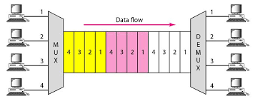

Key Concepts of Time Division Multiplexing (TDM):

* Time Slots: TDM divides the available time on the communication channel into fixed-duration time slots. Each time slot is allocated to a different signal, and during its allocated time, the corresponding signal is transmitted.
* Sequential Transmission: Signals take turns transmitting their data sequentially in a time-sliced manner. The channel bandwidth is divided into multiple time slots, and each signal gets its time slot for data transmission.
* Digital Signal Transmission: TDM is commonly used in digital communication systems, where digital signals are transmitted in discrete bits or frames. The individual signals are packetized into their respective time slots before being sent over the channel.

Process of Time Division Multiplexing:

* Signal Scheduling: Before transmission, the multiple signals are synchronized and scheduled in such a way that they take turns transmitting during their respective time slots. Each signal knows when its time slot occurs in the overall time frame.
* Time Slot Allocation: The communication channel is divided into multiple equal-duration time slots. Each time slot is assigned to a specific signal. For example, if there are four signals to be multiplexed, the channel will have four time slots, and each signal gets one time slot.
* Signal Transmission: During its allocated time slot, each signal transmits its data over the channel. The signals take turns transmitting in a cyclic manner, with each cycle representing one complete rotation through all the signals.
* Signal Demultiplexing: At the receiving end, the composite signal containing all the multiplexed signals is demultiplexed. The receiver identifies and extracts the data from each time slot, separating the individual signals.

Advantages of Time Division Multiplexing:

* Fair Access: Each signal gets an equal share of the transmission time, ensuring fair access to the channel for all participating signals.
* Bursty Data Handling: TDM is well-suited for data streams that are not continuously active. Time slots can be allocated dynamically based on data availability, accommodating bursty traffic patterns efficiently.
* Simplicity: TDM is relatively straightforward to implement and requires minimal overhead for synchronization and demultiplexing.

Limitations of Time Division Multiplexing:

* Fixed Time Slot Allocation: TDM requires a fixed time slot allocation for each signal. This fixed allocation might not be optimal for signals with varying data rates or transmission requirements.
* Inefficiency for Continuous Data Streams: In cases where some signals have continuous data streams, unused time slots may result in underutilization of the channel's capacity.

TDM has been widely used in various applications, including digital voice communication (e.g., T1/E1 lines for telephony), data networks, and other digital communication systems where multiple data streams need to be efficiently combined and transmitted over a single channel.

**Code Division Multiplexing (CDM)**

Code Division Multiplexing (CDM) or Code Division Multiple Access (CDMA) is a multiplexing technique used in communication systems to combine multiple signals or data streams onto a single communication channel. Unlike Frequency Division Multiplexing (FDM) and Time Division Multiplexing (TDM), which allocate separate frequency bands or time slots to each signal, CDMA assigns a unique code to each signal, allowing multiple signals to share the same frequency band or time slot simultaneously.

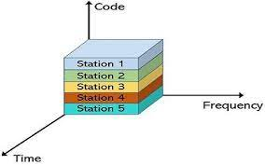

Key Concepts of Code Division Multiplexing (CDM):

* Unique Codes: In CDMA, each signal is assigned a unique spreading code or sequence. These codes are used to spread the individual signals over the entire available frequency spectrum or time domain.
* Shared Spectrum: All signals share the same frequency band or time slot simultaneously. Each signal occupies the entire available bandwidth simultaneously but is distinguishable from other signals by its unique code.
* Signal Separation: At the receiving end, the receiver uses the corresponding code to isolate and extract the specific signal intended for it while suppressing other signals with different codes.

**Process of Code Division Multiplexing:**

* Signal Encoding: Each signal is encoded with its unique spreading code. The spreading code acts as a signature that spreads the signal's bandwidth over the entire channel spectrum.
* Signal Combination: After encoding, the individual signals are combined into a composite signal, which contains all the encoded signals overlapping in the frequency or time domain. The composite signal is then transmitted over the shared communication channel.
* Signal Separation: At the receiving end, the receiver uses the corresponding spreading code to despread (decode) the specific signal intended for it. The unique code allows the receiver to extract the desired signal while attenuating other signals with different codes.

Advantages of Code Division Multiplexing (CDM):

* Efficient Spectrum Utilization: CDMA efficiently utilizes the entire available frequency spectrum by allowing multiple signals to coexist simultaneously without interfering with each other.
* Robustness to Interference: CDMA signals are robust to interference from other signals or noise due to the orthogonality of the spreading codes. Each signal is distinguishable from others, even in the presence of noise and interference.
* Flexibility: CDMA allows for dynamic allocation of bandwidth to users, making it suitable for accommodating varying data rates and changing traffic patterns.
* Security: The unique spreading codes add a level of security to CDMA communication since unauthorized receivers without the correct code will have difficulty decoding the transmitted signals.

Applications of Code Division Multiplexing (CDM)

* Cellular Communication: CDMA is widely used in cellular communication systems, such as 3G (CDMA2000) and 4G (LTE), to accommodate multiple users on the same frequency bands simultaneously.
* Satellite Communication: CDMA is used in satellite communication systems to enable efficient utilization of the limited frequency spectrum available for satellite links.
* Wireless LANs: CDMA-based systems are used in some wireless local area networks (WLANs) to allow multiple devices to share the same communication channel efficiently.

| **Aspect** | **FDM** | **TDM** | **CDM (CDMA)** |
| --- | --- | --- | --- |
| Multiplexing Technique | Frequency Division Multiplexing | Time Division Multiplexing | Code Division Multiplexing |
| Key Principle | Frequency bands are allocated to each signal. | Time slots are allocated to each signal. | Unique codes are assigned to each signal. |
| Channel Access | Simultaneous sharing of different frequency bands. | Sequential sharing through allocated time slots. | Simultaneous sharing using unique codes. |
| Signal Separation | Signals are separated based on their respective frequency bands. | Signals are separated based on their respective time slots. | Signals are separated based on their unique spreading codes. |
| Signal Independence | Signals do not interfere with each other, as they operate in separate frequency bands. | Signals do not interfere with each other, as they operate in separate time slots. | Signals do not interfere with each other, as their unique codes enable distinction. |
| Efficiency | Efficient use of available frequency spectrum. | Efficient use of time slots, suitable for bursty data. | Efficient use of entire frequency spectrum, robust to interference. |
| Application Focus | Analog signal transmission, e.g., cable TV. | Digital signal transmission, e.g., telephony, data networks. | Digital communication systems, e.g., cellular networks, satellite communication. |
| Flexibility | Fixed frequency band allocation. | Fixed time slot allocation. | Dynamic bandwidth allocation for changing data rates. |
| Interference | Signals may interfere if frequency bands overlap. | Signals do not interfere within their allocated time slots. | Signals are robust to interference due to unique codes. |
| Security | Limited security due to lack of unique identification. | Limited security due to fixed time slot allocation. | Enhanced security due to unique codes for each signal. |